Форма заявки 2
Заявка (секции 17 – 20)

Требования к оформлению докладов

Объем не более трех страниц (включая таблицы, иллюстрации, список литературы). Поля: верхнее, левое, правое – 2, нижнее – 3.
Шрифт основного текста TNR, кегль 12, интервал 1,1, абзацный отступ 0,75, выравнивание текста по ширине, автопереносы. Шрифт таблиц и подрисуночных подписей TNR, кегль 10.
Формулы набирать в редакторе Mathtype. Цифры, греческие символы, русские буквы – прямо; латинские – курсивом. Размер шрифта – 12. Формулы должны быть отбиты от предыдущего и последующего текста. Нумерация необходима, если есть ссылки на формулы в тексте.
Если в статье один рисунок (таблица), то он не нумеруется (рисунок, таблица).

Оформление

  - УДК

  - И. О. Фамилия (инициалы перед фамилией)
Институт, университет, страна, город (не обязательно все)

  - Научный руководитель (Language supervisor) – звание, должность И. О. Фамилия
Институт, университет, страна, город (не обязательно все)

  - Заголовок

  - Текст статьи

  - Список литературы (References)

Источники в порядке упоминания в тексте. Оформляется по ГОСТ Р7.05–2008 «Библиографическая ссылка». Курсив не используется.
Статья
Миронов А. Г. Об учете скорости распространения волн // Вестн. ИрГТУ. 2015. № 3. С. 12–18.
Книга
Миронов А. Г. Об учете скорости распространения волн давления. М.: ИНФРА-М, 2015. 128 с.
Книги и статьи более трех авторов
Оптимизация параметров измерительного устройства удельной поверхности сорбентов и катализаторов / С. И. Половнева, С. В. Саливон, А. С. Мальчихин [и др.] // Вестн. ИрГТУ. 2005. № 3. С. 7–10.
Транслитерация используется при необходимости.

УДК 537.6

Z.I. Nazarova, A.N. Nazarov
Students, Siberian Federal University, Russia, Krasnoyarsk
Language supervisor – senior lecturer S.V. Polikarpova
Siberian Federal University, Russia, Krasnoyarsk

Phase formation in thin films of Fe/Si

Technology nowadays moves forward and requires new ways to synthesize different materials with particular properties. For many years, thin films have been one of the most promising fields of research. To obtain required compounds, we need to know the laws and principles of solid-state interactions which take place in thin films.
One of the most successful models of predicting the phase formation sequence is the effective heat of formation (EHF) model [1]. The advantage of the EHF model is that it takes into account the concentration of the reactants at the growth interface, using the equation:

$ΔH’=ΔH^{o}\frac{effective concentration limiting element}{compound concentration limiting element}$ , (1)

where ΔH’ and ΔHº are expressed in kJ per mole of atoms. The element is called the limiting one if its effective concentration is less than its concentration in the compound to be formed. Using equation (1), we can easily calculate the effective heat of formation as a function of concentration of the reacting species. It is done for the Fe-Si binary system in Figure 1.

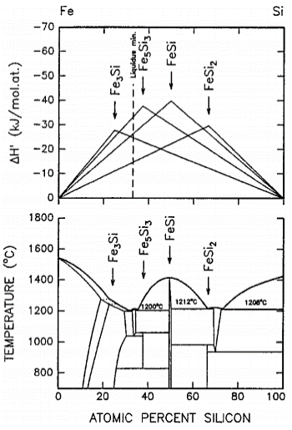
Figure 1. The effective heat of formation (ΔH’) diagram (top)
and the phase diagram (bottom) for the Fe-Si model

To use the EHF model, it is indispensable to know the effective concentration of the reactants at the growth interface. It has been shown that the most effective mixing at the interface takes place at the minimum liquidus of the binary system [2]. Due to this fact the composition at the minimum liquidus is chosen as the effective concentration during solid-state reaction. According to phase diagram, the minimum liquidus is marked as a dashed line in the effective heat of formation diagram.
A phase which has the most negative effective heat of formation is predicted to form first. As one of the elements is consumed, the effective concentration of the element forming a substrate moves to the greater values. Thus, according to the diagram, the formation of the next most preferable phase takes place instead.
Thin films of Fe₃Si have been obtained by vacuum-evaporation technique on installation of molecular beam epitaxy “Angara” [3]. Atomically clean Si (111) substrate has been used. Phase formation has been analysed by transmission electron microscopy (Figures 2-5).

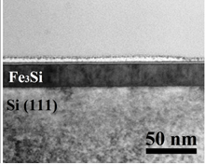
Figure 2. Electron microscope image of Fe₃Si/Si
before annealing (cross-section geometry)
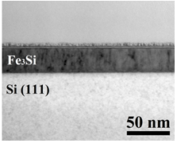
Figure 3. Electron microscope image of Fe₃Si/Si
after annealing at 350°C (cross-section geometry)
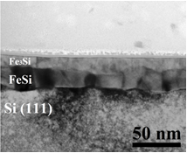
Figure 4. Electron microscope image of Fe₃Si/Si
after annealing at 450°C (cross-section geometry)

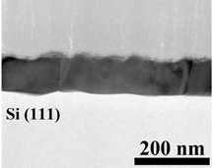
Figure 5. Electron microscope image of Fe3Si/Si
after annealing at 550 °C (cross-section geometry)

Predictions of the EHF model agree with the experimental results.

References

1. Compound Phase Formation in Thin Film Structures / P. René, C. Christiaan, V. André // Critical Reviews in Solid State and Materials Sciences. 1999. №24 (1). P. 1-62.
2. Correlations for Diffusion Constants / A.M. Brown, M.F. Ashby // Acta Metallurgica. 1980. №28. P. 1085–1101.
3. Regularities of phase formation in Fe3Si (111)/Si (111) structure at vacuum annealing / M.N. Volochaev, I.A. Tarasov, U.U. Loginov, A.G. Cherkov, I.V. Kovalev // Journal of Physics: Conference Series. 2017. № 857. P. 012053.

